I used the Downloaded file because my internet connection was poor for the first question and just went with it for the rest.

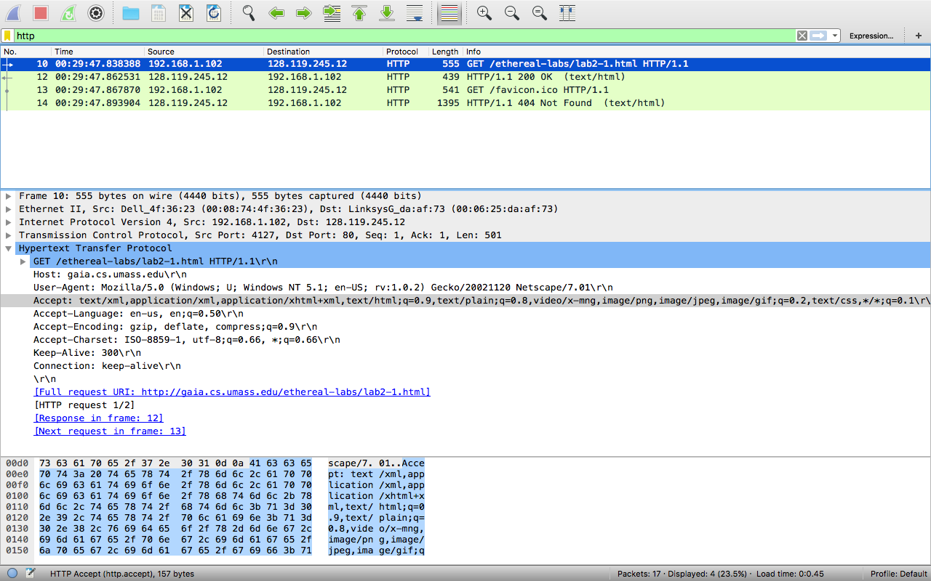 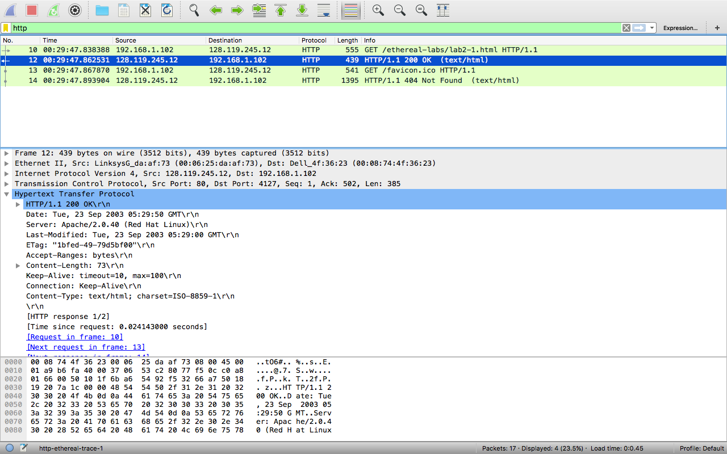

1.1) HTTP 1.1

1.2) Accept: text/html,application/xhtml+xml,application/xml;q=0.9,image/webp,\*/\*;q=0.8\r\n

1.3) destination IP: 192.168.1.102, Gaia IP: 128.119.245.12

1.4) 200

1.5)Tue, 23 Sep 2003 05:29:00 GMT

1.6) 73 Bytes

1.7) I couldn’t see any extra content in the header

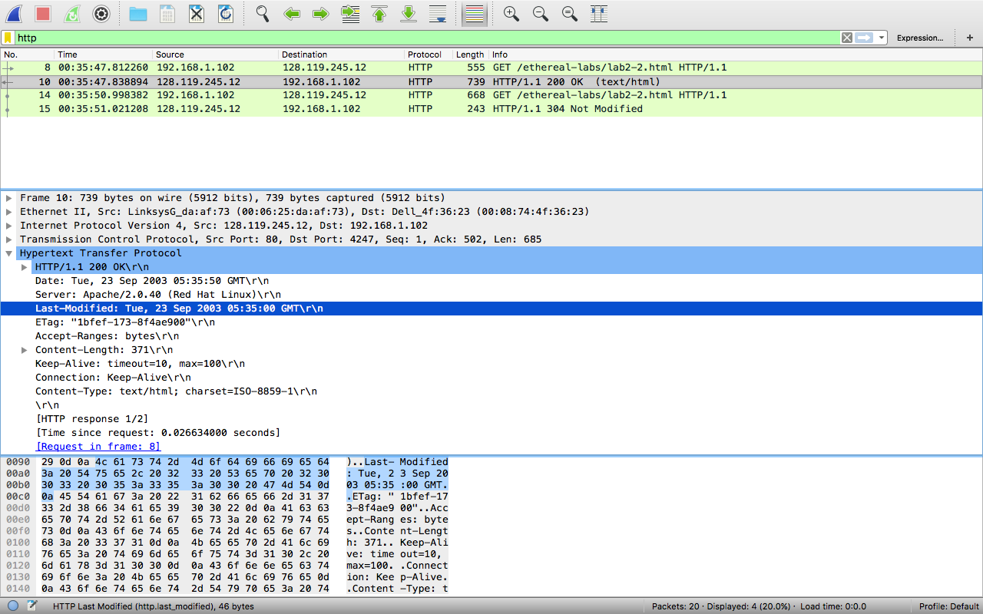

2.8) no I do not, however there is one in the second request.

2.9) yes it did. Because I can read the included html

2.10) yes, If-Modified-Since: Tue, 23 Sep 2003 05:35:00 GMT

2.11) 304 not modified

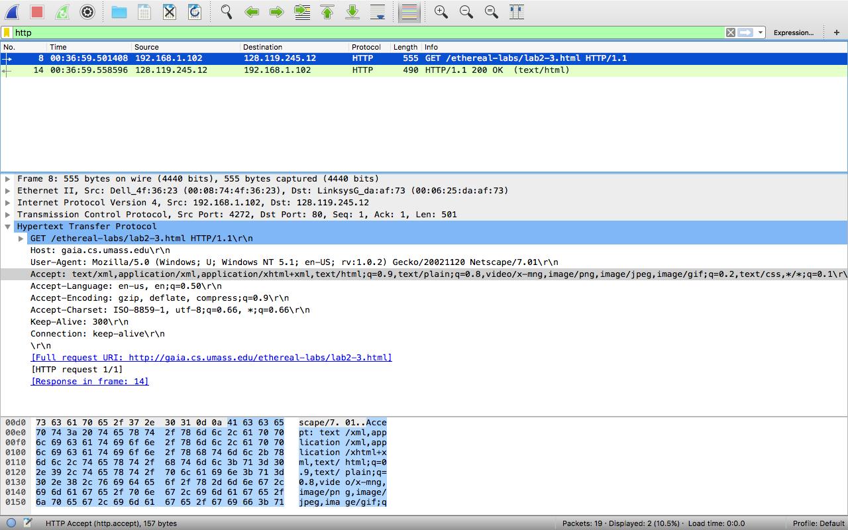 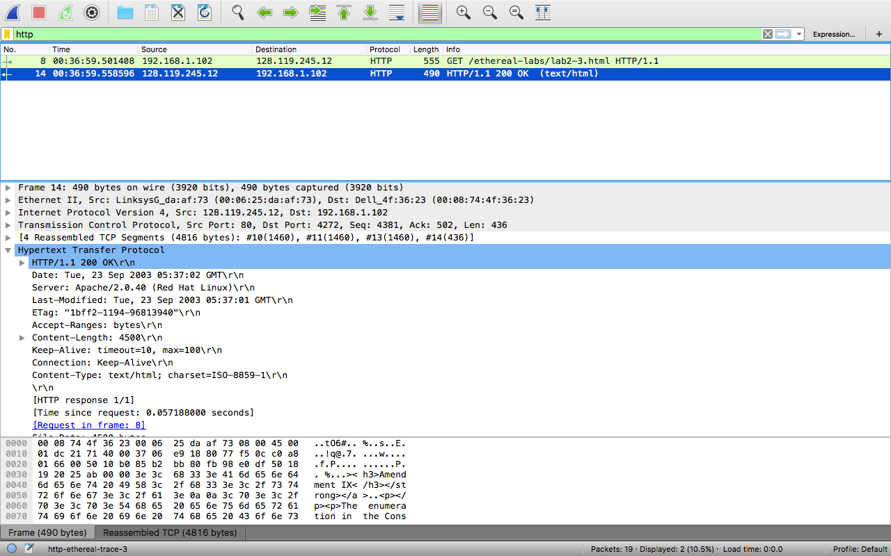

3.12) 1

3.13) packet 8. Phrase was GET

3.14) 200 OK

3.15) 4

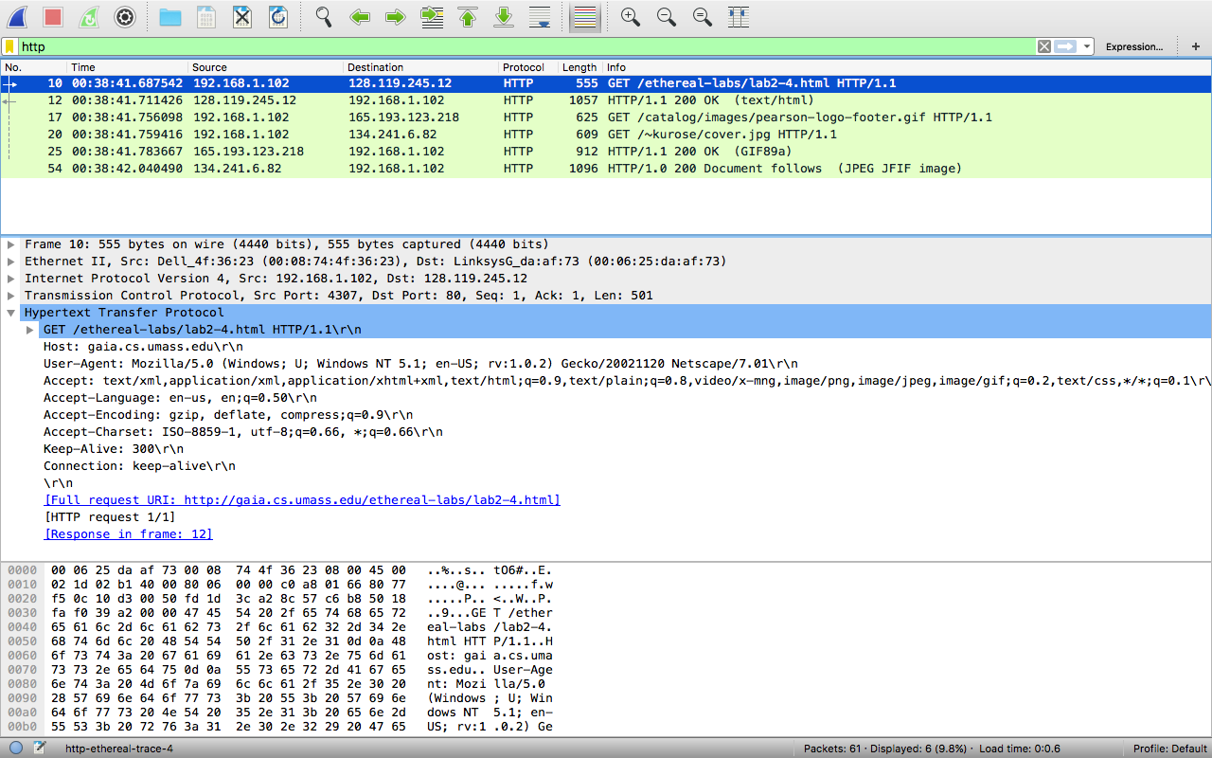

4.16) 3 GET requests

4.17) It looks like they were downloaded in parallel. Both get requests went through before the data was received.

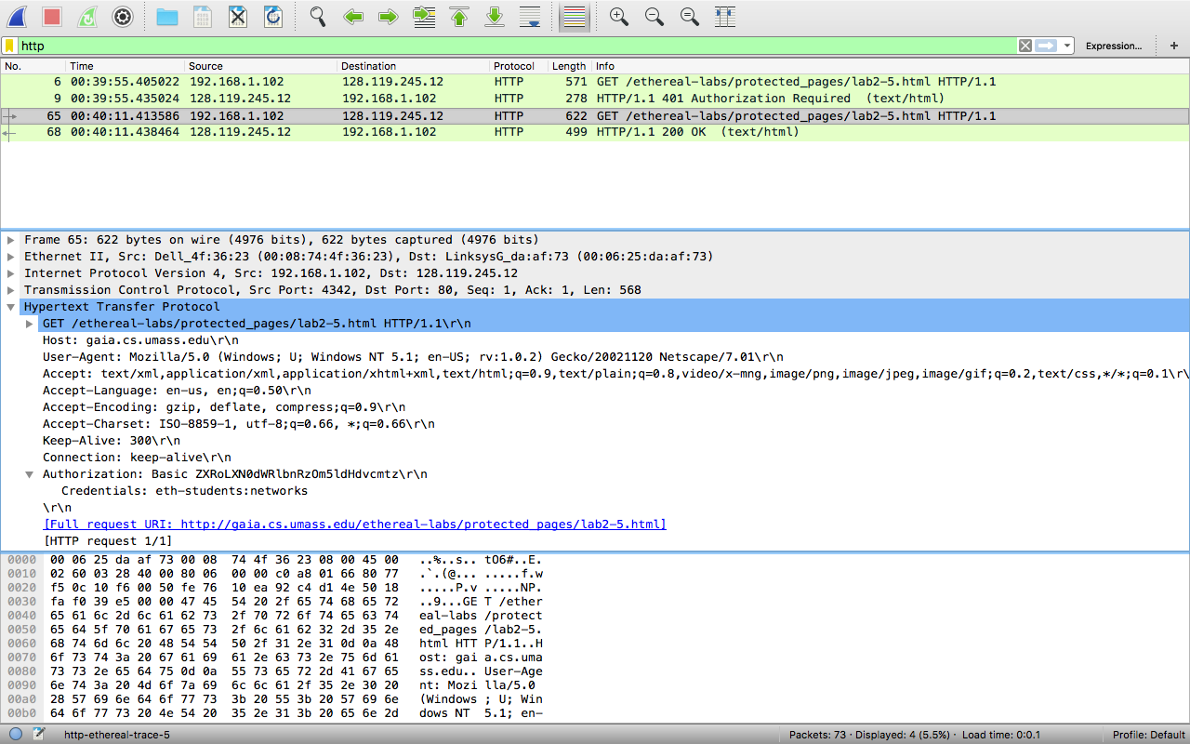

5.18) message 401 AUTHORIZATION REQUIRED

5.19) It looks like it is a line called authorization: with a type and credentials